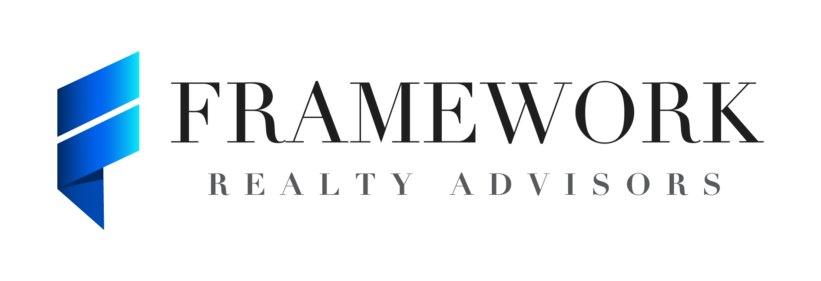

825 Watters Creek Blvd., Building M, Suite 250

Allen, TX 75013

Framework Realty Advisors (“FRA”) has been engaged on an exclusive basis by SMC Management, (the “Company”) in connection with a possible investment opportunity (a “Transaction”) related to The Arbors at Winthrop, located at 46 Lincoln St., Winthrop (Boston MSA), Massachusetts, 02152. In order to receive Confidential Information (as defined below) regarding the Company, you agree as follows:

- As used herein, the following terms have the following meanings:

“Confidential Information” means all oral and written information and material relating to the Company, FRA, or a Transaction, including the identity of the Company, the fact that the Company is considering a Transaction or has provided information to a Receiving Party, and any information concerning the business, financial condition, projections, operations, customers, "know-how" and methodologies of the Company, in any form, including electronic or optical data storage systems, written or verbal, as well as any information observed during facility tours, regardless of whether protected by trade secret laws and regardless of whether marked “confidential,” and any analyses, memoranda or reports prepared by you or your Representatives reflecting any such information, provided however, Confidential Information does not include (i) information that was, is or becomes generally available to participants in the Company’s industry or to the public other than as a result of a disclosure by you or any of your Representatives in breach of this Agreement or any other contractual, fiduciary or legal obligation, (ii) information that was within your or your Representative’s possession prior to being furnished to you or your Representatives pursuant hereto, as evidenced by written records, provided that the source, to your knowledge or the knowledge of your Representatives, is not, by virtue of such disclosure, in breach of any contractual, fiduciary, or legal obligation, (iii) information that is lawfully obtained by you or any of your Representatives hereafter from a source that, in each case, to your knowledge or the knowledge of your Representative, is not, by virtue of such disclosure, in breach of any contractual, fiduciary or legal obligation, or (iv) information independently developed by or for you or one of your Representatives without access to other Confidential Information.

“Receiving Party” means you or any of your Representatives who receive Confidential Information.

“Representative” means, with respect to any person, the directors, managers, members, officers, employees, affiliates, agents, consultants, partners, advisors, counsel, financing sources, auditors, and/or the representatives of such person.

- Restrictions on Use and Disclosure. A Receiving Party, except as otherwise set forth in this Agreement, shall (i) use such Confidential Information solely for the purpose of evaluating or consummating its or an affiliate’s possible participation as the buyer in the Transaction (the “Permitted Purpose”) and not use Confidential Information for any other purpose and (ii) keep confidential and not disclose the Confidential Information to any person. This is not a brokerage commission agreement and neither you nor your Representatives may disclose any confidential information to any other prospective buyer.

- Permitted Disclosure. Confidential Information may be disclosed as follows: (i) you may disclose Confidential Information to your Representatives with a need to know solely for the Permitted Purpose, provided that you shall inform such Representatives of the confidential nature of Confidential Information, direct them to treat Confidential Information in accordance with the terms of this Agreement and you shall be responsible for any breach of this Agreement that results from the actions or omissions of such Representatives, and (ii) a Receiving Party may disclose Confidential Information to the extent required by law, subpoena or other legal process or as otherwise requested by any governmental agency or regulatory authority in any action, proceeding or arbitration to which the Receiving Party is a party; provided that if the Receiving Party discloses or intends to disclose any Confidential Information to a person pursuant to this subparagraph (ii), then the Receiving Party will inform such person of the confidential nature of such information and, to the extent not prohibited by any law, regulation or court order, notify the Company of such disclosure promptly and reasonably cooperate with the Company in lawful efforts, at the Company’s expense, to resist disclosure and/or to obtain confidential treatment of such Confidential Information by the persons to whom it is disclosed. Notwithstanding the foregoing any such information may be disclosed by the Receiving Party when pursuant to an ordinary course examination by a regulator, bank examiner, or self-regulatory organization not specifically directed at the Company, the Transaction contemplated by this Agreement or the Confidential Information. The Company hereby acknowledges that if Receiving Party consummates a transaction, Receiving Party may enter into an agreement with an independent tenant/operator with respect to the asset and therefore agrees that Receiving Party may provide potential tenant/operators with copies of the Confidential Information subject to the provisions hereof.

- Return of Confidential Information. Upon written request of the Company, all Receiving Parties shall return to the Company or destroy (and certify such destruction in writing – via email is acceptable) as soon as practical all Confidential Information received by them, without retaining any copies thereof unless such copies are retained by the Receiving Party to comply with their respective internal compliance policies only or in accordance with applicable law or regulation. Each Receiving Party shall hold any such retained information in accordance with the terms of this agreement.

- Remedies. In the event of a material breach of this Agreement by a Receiving Party, you agree that the Company may be entitled to seek equitable relief, including temporary, preliminary and permanent injunctions and specific performance, enjoining any threatened or further breach of this Agreement. The Company shall notify Receiving Party in writing of any claim under this Agreement on or before the anniversary of the date of this Agreement. Notwithstanding any longer statutory period for making claims, the Company’s right to make a claim after that date shall terminate. Each party acknowledges that this private limitation on the time for making any claim is a material part of the consideration of this Agreement.

- No Fiduciary Relationship. Neither this Agreement, nor any exchange of Confidential Information under it, will be construed as creating any fiduciary, advisory or other relationship or obligation of any kind between the parties beyond the terms of this Agreement.

- No Contacts. No Receiving Party shall, directly or indirectly, discuss any of the Confidential Information or the terms of a Transaction with any officer or employee or any vendor, supplier, distributor, licensor, licensee, lessee, or customer of the Company, unless such communication or contact has been specifically authorized in writing by us or the Company; except that, nothing in this section will prevent Receiving Party from conducting market diligence, which may include contact with customers and suppliers of the Company, to the extent Receiving Party does not disclose that the Company is pursuing the Transaction.

- Nonsolicitation. For a period of twelve (12) months from the date hereof, you agree that no Receiving Party will, directly or indirectly, solicit any individual who is now an employee or independent contractor of the Company or current Lessee (operator), and with whom it first has contact in connection with evaluation of a Transaction (a “Protected Employee”) for employment or retention as an independent contractor. Notwithstanding the foregoing, nothing in this paragraph shall prohibit a Receiving Party from making general solicitations of employment through (i) mass media advertisements, or (ii) a recruiting agency acting on its behalf, provided that such recruiting agency is not directed to target Protected Employees. Receiving Party shall not be in violation of this Section 8 if a Protected Employee first contacts such Receiving Party.

- No Commitment to Transaction. This agreement does not obligate the Company or its Representatives to provide any Confidential Information to you or your Representatives. Neither this Agreement nor any discussions or course of dealing between you and the Company or its Representatives obligates you or the Company or any of their respective Representatives to negotiate with respect to or enter into a Transaction. Without limiting the generality of the foregoing, the Company may provide Confidential Information to, and negotiate with respect to or enter into a Transaction with, other persons.
- No Representations. Neither the Company, FRA nor any of their respective Representatives makes any representation or warranty as to the accuracy or completeness of the Confidential Information, except for any representations and warranties made by the Company or Seller and expressly set forth in definitive agreements for a Transaction.

- Termination. This Agreement and all obligations hereunder, shall terminate upon the earlier of one year after the date of this Agreement, or the consummation of a definitive agreement between the Company and you regarding the Transaction.

- Entire Agreement. This Agreement embodies the entire understanding between the parties with respect to its subject matter and supersedes any prior agreements relating thereto. This Agreement may only be modified in writing signed by the party to be bound thereby.

- Third Party Beneficiary. You acknowledge and agree that the Seller is an intended third party beneficiary of this agreement and shall be entitled to enforce this agreement as if a signatory hereto. We and/or the Company shall have the right to assign our rights hereunder.

- Law and Jurisdiction. This agreement shall be governed by and construed in accordance with the internal laws of the State of Massachusetts without regard to the principles of conflicts of law.

- Miscellaneous. This agreement is binding upon and shall inure to the benefit of the parties signing this agreement. Any modifications to this agreement shall be ineffective unless the same are in writing and signed by the authorized representatives of all parties. If any provision of this agreement is determined by a court of law to be unenforceable, remaining provisions shall remain in full force and effect. This agreement may be executed in any number of counterparts.

- “Click-Through” Agreements. The terms of this Agreement shall control over any additional purported confidentiality requirements imposed by an offering memorandum, web-based database, or similar repository of information to which Receiving Party is granted access in connection with this Agreement or the Transaction, notwithstanding acceptance of such an offering memorandum or submission of an electronic signature, “Clicking” on an “I Agree” icon or other indication of assent to such additional confidentiality conditions, it being understood and agreed that Receiving Party’s confidentiality obligations with respect to the confidential information are exclusively governed by this Agreement and may not be enlarged except by an agreement executed by the parties hereto in traditional written format.

If you agree to the foregoing, please sign and return a copy of this agreement. Thank you for your interest in the Company and we look forward to working with you on a potential Transaction.
Confirmed and Agreed to:

By: ___________________________________________
Name: ____________________________________
Title: _____________________________________
Company: _________________________________
Date: ______________________________________
Sincerely,

Framework Realty Advisors
Michael Girard
Managing Member

PLEASE RETURN EXECUTED NDA TO MIKE@FRAMEWORKRA.COM

